# Introduction

In the present paper we repeat the experiment by John R. Stroop to determine if the Stroop effect (1935) – a conflict between automated and controlled processes – was present within our subjects. Such effect reflects how attention is a limited resource (Radvansky & Ashcraft, 2014). If the effect is present, we would expect to see a higher reaction time (RT) and number of errors in trials that require greater inhibition of automated actions, such as naming colour in incongruent trials compared to congruent ones (Stroop, 1935).

The experiment consisted of two parts, each testing different hypotheses. Part 1 tested the effect of meaningful words on naming ink colour, and part 2 tested the effect of ink colour on naming words.

# Method

This experiment had an overall of *N* = 110 participants, all psychology students at university level. Age and sex differences were not considered.

## Material

* Stroop reading lists
  + List 1: incongruence between words and ink colour
  + List 2: coloured X’s
  + List 3: list of colour names printed in black
* Stopwatch
* Error check list

## Test procedure

Before each trial, the participant was given the appropriate instructions by the experimenter. Throughout the experiment, observer 1 (O1) and observer 2 (O2) recorded reaction times in whole seconds. The experimenter recorded number of errors.

In part 1, the participant was asked to name ink colour of words using List 1, followed by naming ink colour of X’s using List 2.

In part 2, the participant was asked to read colour names, rather than ink colour, using List 1, followed by naming colour names using List 3.

The experiment was repeated with two other participants.

# Results

## Descriptive statistics

Table 1 is a summary of RT and average number of errors for each of the four conditions.

|  |  |  |  |  |  |  |  |  |  |  |  |  |
| --- | --- | --- | --- | --- | --- | --- | --- | --- | --- | --- | --- | --- |
| Table 1  *Average time usage and number of errors under the four experimental conditions* | | | | | | | | | | | | |
|  |  | Naming colour | | | | |  | Naming word | | | | |
|  |  | Incongruent word | |  | XXX | |  | Incongruent colour | |  | Black and white | |
|  |  | *M* | *(SD)* |  | *M* | *(SD)* |  | *M* | *(SD)* |  | *M* | *(SD)* |
| Time usage |  | 96.94 | *(18.22)* |  | *62.74* | *(10.23)* |  | *46.15* | *(9.83)* |  | *38.95* | *(5.54)* |
| Errors |  | 1.68 | *(2.20)* |  | *0.68* | *(0.99)* |  | *0.56* | *(0.89)* |  | *0.46* | *(0.82)* |
| *Note*. Time usage is measured in seconds and errors are shown in number of errors. *N* = 110. | | | | | | | | | | | | |

## Mean time usage varied considerable throughout the conditions

A repeated measures ANOVA was conducted to test whether time usage was significantly different within the four conditions.

The test showed a significant effect of conditions on time usage, *F*(1.956, 213.195) = 940.044, *p* < .001, $η_{p}^{2}=.896$ (Huynh-Feldt corrected). Table 1 shows mean time usage in each of the four conditions, and this is illustrated graphically in Figure 1. These results suggest that naming colour was more demanding than naming words, with naming incongruent colours being the most demanding (*M* = 96.94, *SD* = 18.22), which would be consistent with the Stroop effect (1935), as List 1 requires inhibition of the automatic process of reading.

Figure 2 reveals the same pattern for our select participants, suggesting the effect may be present even when using much smaller samples *(N* = 3)*.*

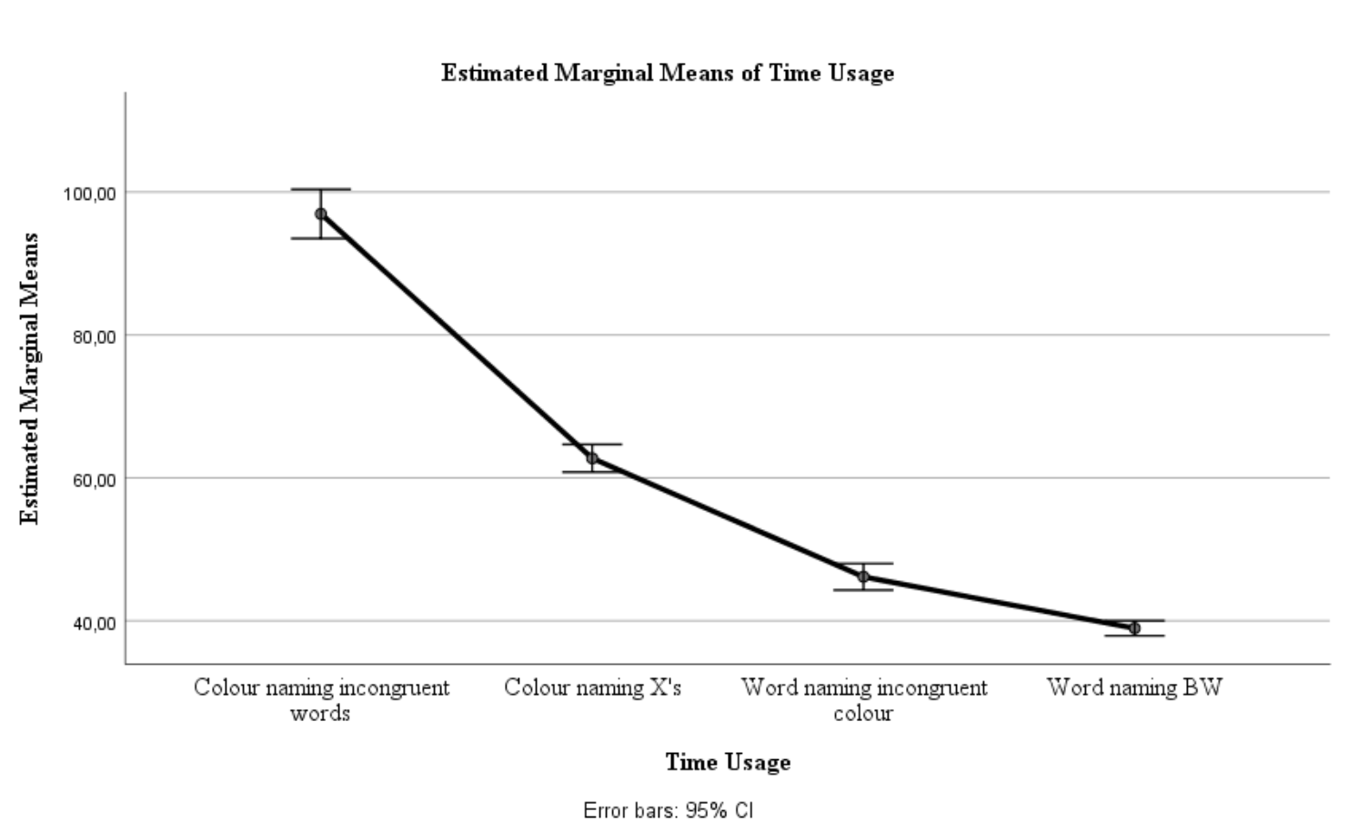

Figure 1: Mean time usage in the four conditions for the entire sample. Mean time usage was reduced significantly throughout the conditions.

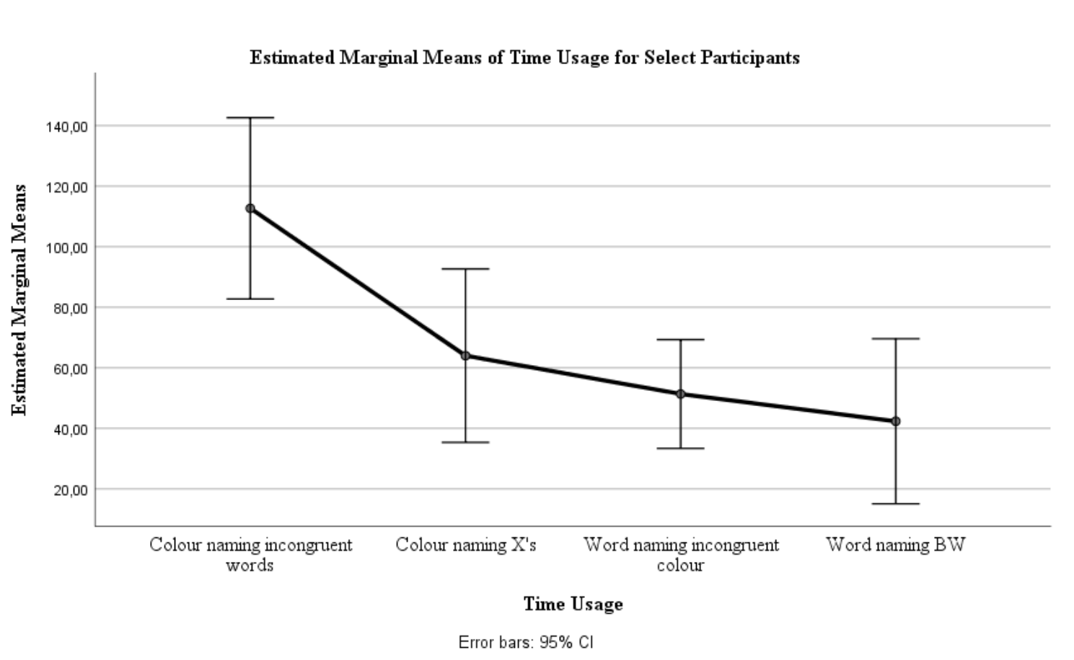

Figure 2: Mean time usage in the four conditions for select participants. Mean time usage was reduced significantly throughout the conditions.

## Controlled processes inhibit the automatic process of reading

A paired samples *t*-test was conducted to test whether time usage was significantly longer for colour naming incongruent words (List 1) or for colour naming X’s (List 2). The *t*-test (two-tailed, α = .05) showed that time usage was significantly longer for List 1 (*M* = 96.94, *SD* = 18.22) than for List 2 (*M* = 62.73, *SD* = 10.23), *t*(109) = 28.64, *p* < .001, *d* = 2.40.

These results support the notion that the controlled process of naming colours is inhibited by the automatic process of reading present only in List 1 as compared to List 2.

## Colour incongruency causes conflict to the process of reading

A paired samples *t*-test was conducted to test whether time usage was significantly longer for word naming with incongruent colour (List 1) or for word naming in black ink (List 3). This *t*-test (two-tailed, α = .05) showed that time usage was significantly longer for List 1 (*M* = 46.15, *SD* = 9.83) than for List 3 (*M* = 38.95, *SD* = 5.54), *t*(109) = 9.51, *p* < .001, *d* = 0.94.

These results suggest that the colour incongruency of List 1 caused some conflict to the automatic process of reading.

## Processes demanding large amounts of control yield the most errors

A repeated measures ANOVA was conducted to test whether there was a significant difference between number of errors in the four conditions, illustrated in Figure 3.

The test showed a significant effect of conditions on number of errors, *F*(1.825, 198.962) = 24.70, *p* < .001, $η_{p}^{2}=.185$ (Huynh-Feldt corrected).

These results were consistent with our expectations and mirrors the differences in mean time usage for the four conditions (Figure 1). This is consistent with the Stroop effect (1935) as we would expect more errors to be made during trials demanding more control due to conflict and mental fatigue (Purves et al., 2013; Radvansky & Ashcraft, 2014).

Figure 4 reveals a similar pattern for select participants (*N* = 3). However, the differences between conditions 1 and 2 were not as drastic.

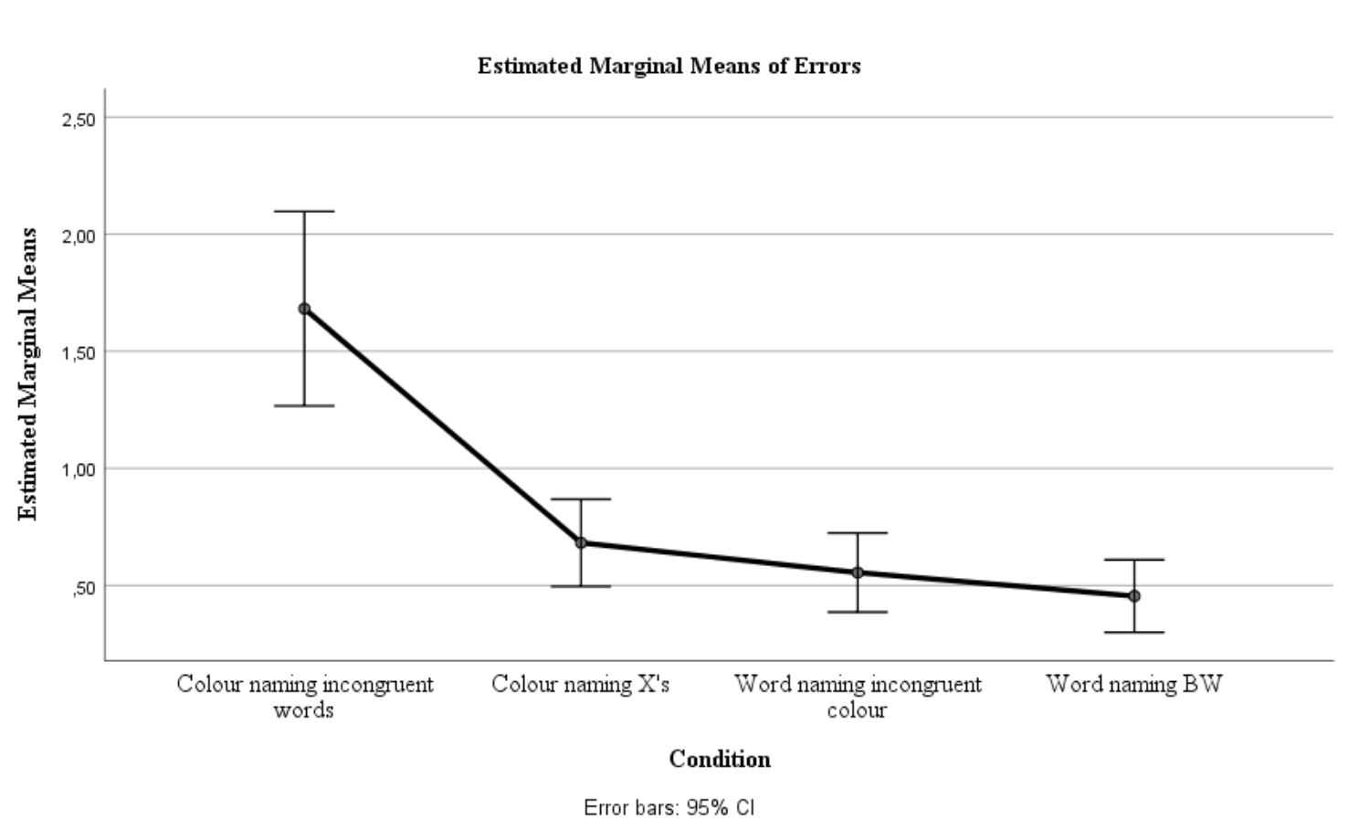

Figure 3: Mean number of errors in the four conditions for the entire sample. Conditions demanding the most inhibition showed the greatest number of errors.

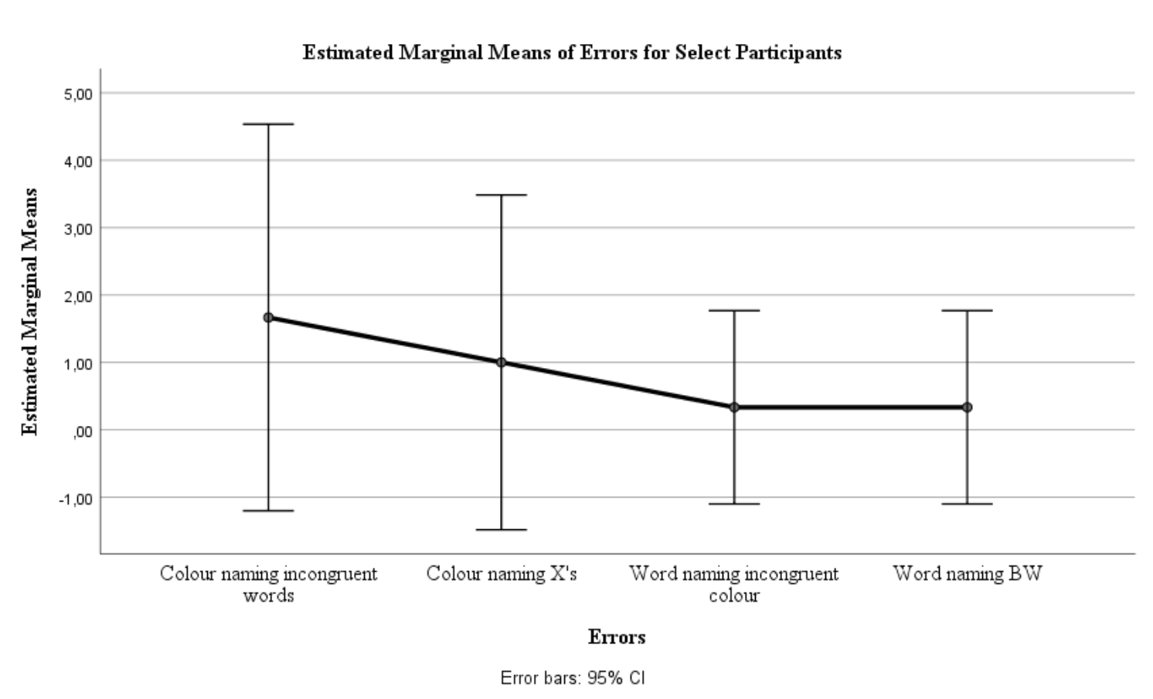

Figure 4: Mean number of errors in the four conditions for select participants. Conditions demanding the most inhibition showed the greatest number of errors.

## Inhibition occurs when an automatic process needs to be suppressed

A paired samples *t*-test (two-tailed, α = .05) showed that participants made significantly more errors when colour naming incongruent words (*M* = 1.68, *SD* = 2.20) than when colour naming X’s (*M* = 0.68, *SD* = 0.99), *t*(109) = 4.81, *p* < .001, *d* = 1.65. This supports the notion that condition 1 was more cognitively demanding, as outlined above.

Further, a paired samples *t*-test (two-tailed, α = .05) showed that there was no significant difference between number of errors made when word naming coloured words (*M* = 0.55, *SD* = 0.89) and naming words in black ink (*M* = 0.45, *SD* = 0.82), *t*(109) = 1.07, *p* = .285, *d* = 0.86.

These results suggest that the automatic process of reading is not inhibited by incongruent ink colours. Rather, inhibition occurs when this automatic process needs to be suppressed.

# Conclusion

The experiment successfully showed the Stroop effect (1935) amongst our sample. Our results provide evidence that mental resources will be exhausted whilst performing controlled tasks and purposely supressing automatic processes. This reflects how attention is a limited resource (Radvansky & Ashcraft, 2014).

# References

Purves, D., Cabeza, R., Huettel, S. A., LaBar, K. S., Platt, M. L., & Woldorff, M. G. (2013). *Principles of Cognitive Neuroscience* (2nd ed.). Sunderland, Massachusetts: Sinauer Associates, Inc., Publishers.

Radvansky, G. A., & Ashcraft, M. H. (2014). *Cognition* (6th ed.). Upper Saddle River: Pearson Education.

Stroop, J. R. (1935). Studies of Interference in Serial Verbal Reactions. *Journal of Experimental Psychology*, *18*(6), 643–661.